# Requirements – Student #3

Please, fill in the following form, make sure that you have ticked the requirements that you consider fulfilled, save this document, **and attach it in its original format (.docx)** to every deliverable. Regarding your ID, please keep only four random digits and mask the others using an asterisk. **Please, note that this document must be edited with the desktop version of Word since the web version does not properly support forms.** Attaching this document entails that you are the authors of the work delivered, you have not cheated in any way, and you have read and understood the information delivered regarding the subject, with a special emphasis on the methodological guidelines and how your work is going to be graded. Make sure that your project works well with the latest version of the development framework.

|  |
| --- |
| **Group:** C1.031 |
| **Repository:** https://github.com/aaronma300604/DP2-C01-31 |
| Student #2  **ID Number:** 546*****  **UVUS:**  PLF8407  **Name:**  Miranda Balastegui, Iván  **Roles:**  tester, developer, operator |
| **Date:** Seville February 20, 2025 |

# MANDATORY Deliverable D01: introduction

## Information requirements

Intentionally blank.

## Functional requirements

1. Modify the anonymous menu so that it shows an option that takes the browser to the home page of your favourite web site. The title must read as follows: “〈id-number〉: 〈surname〉, 〈name〉”, where “〈id-number〉” denotes your DNI, NIE, or passport number, “〈surname〉” denotes your surname/s, and “〈name〉” denotes your name/s.

X

## Non-functional requirements

Intentionally blank.

## Testing requirements

Intentionally blank.

## Managerial requirements

1. Provide a link to your planning dashboard in GitHub to review the tasks, their current status, and your schedule.

X Mismos problemas que los indicados en el documento de tareas grupales.

**--CORRECCION ESTUDIANTE—**

Respecto a la falta de diversas issues en el dashboard, se ha procedido a crear nuevas issues para la si-guiente convocatoria haciendo referencia a las tareas realizar necesarias indicadas en la asignatura:

# MANDATORY Deliverable D02: data models

## Information requirements

1. The **flight crew members** are the people responsible for operating aircrafts and ensuring passenger safety and comfort during a flight. The system must store the following data about them: an **employee code** (unique, pattern "^[A-Z]{2-3}\d{6}$", where the first two or three letters correspond to their initials), a **phone number** (pattern "^\+?\d{6,15}$"), their **language skills** (up to 255 characters), their **availability status** ("AVAILABLE", "ON VACATION", "ON LEAVE"), the **airline** they are working for, and their **salary**. Optionally, the system may store his or her **years of experience**.

X No se ha definido el patrón indicado para el employee code en el modelo

**--CORRECCION ESTUDIANTE—**

Este sí se define, pero en un validador creado para la clase denominado FligthCrewMemberValidator, este es llamado mediante el índice ValidFlightCrewMember. Sin embargo, se ha añadido a la propiedad del rol el @ValidString necesario:

1. A **flight assignment** represents the allocation of a **flight crew member** to a specific **leg** of a flight. Each assignment specifies the flight crew's **duty** in that leg ("PILOT", "CO-PILOT", "LEAD ATTENDANT", "CABIN ATTENDANT"), the **moment** of the last update (in the past), the **current status** of the assignment ("CONFIRMED", "PENDING", or "CANCELLED"), and some **remarks** (up to 255 characters), if necessary.

X

1. An **activity log** records incidents that occur during a flight. They are logged by any of the **flight crew members** assigned to the corresponding leg and after the **leg** has taken place. The incidents include weather-related disruptions, route deviations, passenger issues, or mechanical failures, to mention a few. Each log entry includes a **registration** **moment** (in the past), a **type of incident** (up to 50 characters) a **description** (up to 255 characters), and a **severity level** (ranging from 0 to 10, where 0 indicates no issue and 10 represents a highly critical situation).

X

## Functional requirements

Intentionally blank.

## Non-functional requirements

Intentionally blank.

## Testing requirements

1. Produce assorted sample data to test your application informally. The data must include four **flight crew** **member** accounts with credentials “**memberX**/**memberX**” with X ranging from 1 to 4 (and different duties each). Additionally, create a fifth member account **member/member**,representing a new member with no flight assignment, as if the account had just been created.

X

## Managerial requirements

1. Provide a link to your planning dashboard in GitHub to review the tasks, their current status, and your schedule.

X

# MANDATORY Deliverable D03: implementing features

## Information requirements

Intentionally blank.

## Functional requirements

1. Operations by **flight crew members** on **flight assignments**:

* List the flight assignments separately, one for completed flight legs and another one for those planned but that have not taken place yet.
* Show the details of their flight assignments and the associated legs and flight crew members.
* Create, update, and publish their flight assignments. Only crew members with duty “LEAD ATTENDANT” can perform these operations. Please, note that to publish a flight assignment these cannot be linked to legs that have already occurred. Additionally, only flight crew members with an "AVAILABLE" status can be assigned to a leg, and they cannot be assigned to multiple legs simultaneously. Lastly, each leg can only have one pilot and one co-pilot. The allocation of remaining roles for other flight crew members is at the discretion of the “LEAD ATTENDANT”. Flight assignments can be updated or deleted as long as they have not been published.

Hay problemas de internacionalización

El campo last update debería de ser un campo calculado y de solo lectura. Es cierto que se calcula automáticamente pero permite al usuario modificarlo:

Cuando intento publicar un assignement se indica que no se puede publicar porque la leg no está publicada. Los crew members no pueden ver legs que no están publicadas, solo los managers propietarios de las legs pueden ver sus legs no publicadas, nadie más. En la lista desplegable solo se pueden cargar legs publicadas y que aún no hayan tenido lugar. Además, cuando se muestra el error de validación, ahora en la lista desplegable se muestran todas las legs (independientemente de si están publicadas o no, si están en el presente o en el futuro).

Si asigno una leg que ya ha tenido lugar, ahora se muestra en la otra opción del menú, la de las legs completed. Si hago clic en publicar, dice que la leg debe estar completada, lo cuál no entiendo. Ni siquiera debería de salir el para publicar una assignment de una leg que ya ha tenido lugar, como es el caso de la que tengo puesta en la lista desplegable, que ha tenido lugar el 2022/01/10 y la fecha del sistema es 2022/07/30 00:00.

**--CORRECCION ESTUDIANTE—**

En cuanto a los errores de internacionalización se ha procedido a añadir entradas al fichero messages-es.i18n

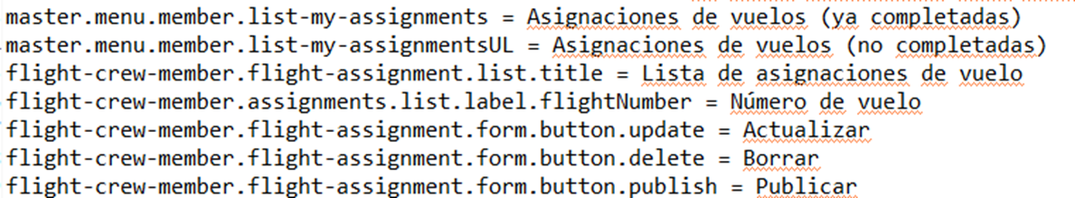

Siguiendo con el error que permite actualizar de manera manual la fecha de úlitma actualización

Se ha añadido al fichero form.jsp de las asignaciones de vuelo la propiedad readOnly=true al componente que hace referencia a la última actualización.

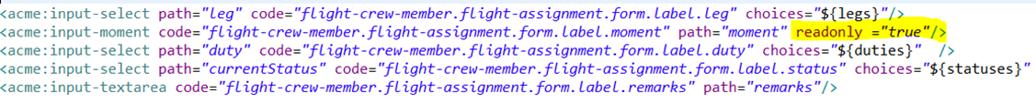

Por otro lado se ha modificado en la clase FlightAssignmentUpdateService, FlightAssignmentCreateService y FlightAssignmentPublishService el método bind para que la fecha se actualice automáticamente cuando se vaya a actualizar, crear o publicar el formulario de asignación de vuelo.

Respecto a los errores comentados sobre el desplegable de las legs, se ha procedido a cambiar el csv de las asignaciones de vuelo “flight-assigment.csv” para que solo existan asignaciones de vuelo conectadas con legs ya publicadas:

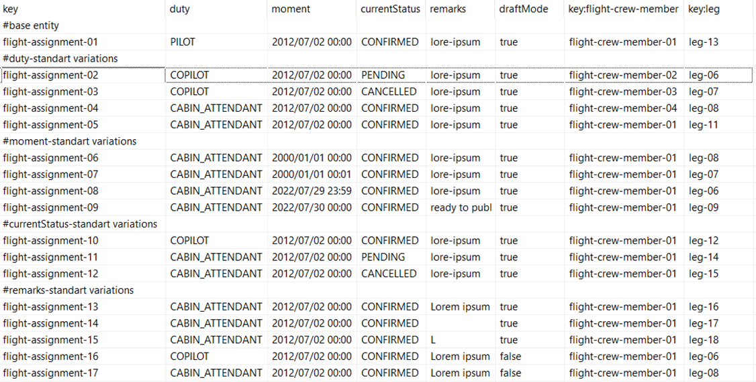

También se han modificado las peticiones a la base de datos para que solo recopilen asignaciones de vuelo conectadas con legs ya publicadas (En principio no sería necesario puesto que la base de datos no cuenta con ninguna asignación de vuelo con asignaciones de vuelo no publicadas. Sin embargo, se ha decidido dicha modificación con el objetivo de que bajo ningún concepto se pudieran llegar a mostrar asignaciones de vuelo con legs no publicadas)



Siguiendo con los desplegables de los formularios de las asignaciones de vuelo, se ha modificado la función getPosibleLegs en los diferentes servicios ,para que solo muestre las legs ya publicadas y futuras, tal y como se indica en la corrección.

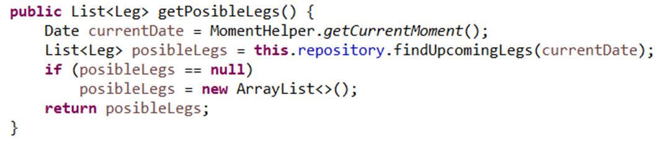

Con este cambio, las asignaciones de vuelo asociadas a legs ya completadas que no se hayan publicado todavía, tendrán un desplegable en el que no tendrá ninguna leg asociada ya completada pero tendrá todas las demás no completadas para poder seleccionar, con el objetivo de poder reutilizar la asignación de vuelo, para ello se ha llevado a cabo una pequeña modificación en el método unbind del servicio FlightAs-signmentShowService, FlightAssignmentUpdateService y FlightAssignmentPublishService.

Para FlightAssignmentShowService.

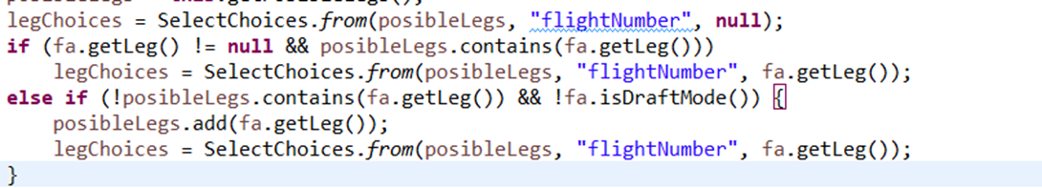

Para FlightAssignmentUpdateService , FlightAssignmentPublishService, FlightAssignmentDeleteService.

Ejemplo de vista de una asignación de vuelo no publicada con una leg pasada:

Por último, el error relacionado con incoherencies de la leg completa o incompleta a la hora de publicar un flight assignment, así como el botón de publicar que no debe aparecer en un flight assignment con una leg ya completada:

El mensaje de comprobación está mal escrito ya que debería indicar que la leg debe estar sin completar para poder ser publicada. Para solucionar este error se ha añadido al dataset el valor booleano showActivityLogs que servirá para saber si la leg asociada a la asignación de vuelo es pasada o futura, lo que permitirá identificar si debe aparecer o no, el botón publish según si la leg asociada de la asignación de vuelo es pasada o futura, así como hacer que el botón ActivityLogs solo aparezca en las asignaciones de vuelo ya completadas. Por otro lado se ha mantenido la comprobación para que una asignación de vuelo no se pueda publicar si la leg asociada ya está completada.

Asignación de vuelo asociada a leg ya completada sin publicar:

Asignación de vuelo asociada a leg no completada sin publicar:

1. Operations by **flight crew members** on **activity log records**:

* List the activity log records in their flight assignments.
* Show the details of their activity log records.
* Create, update, delete and publish activity log records. They cannot be published if their corresponding flight assignments have not been published yet. No updating or deletion is possible once an activity log record has been published.

X

## Non-functional requirements

Intentionally blank.

## Testing requirements

Intentionally blank.

## Managerial requirements

1. Provide a link to your planning dashboard in GitHub to review the tasks, their current status, and your schedule.

X

# MANDATORY Deliverable D04: formal testing

## Information requirements

1. Create appropriate indices for your entities, if required.

X

## Functional requirements

Intentionally blank.

## Non-functional requirements

Intentionally blank.

## Testing requirements

1. Produce a test suite for Requirements #8 and #9.

X

## Managerial requirements

1. Provide a link to your planning dashboard in GitHub to review the tasks, their current status, and your schedule.

X

1. Produce a testing report.

X

# SUPPLEMENTARY I Deliverable D01: introduction

## Information requirements

Intentionally blank.

## Functional requirements

Intentionally blank.

## Non-functional requirements

Intentionally blank.

## Testing requirements

Intentionally blank.

## Managerial requirements

Intentionally blank.

# SUPPLEMENTARY I Deliverable D02: data models

## Information requirements

1. The system must handle **flight crew member** **dashboards** with the following **indicators**:

* The last five destinations to which they have been assigned.
* The number of legs that have an activity log record with an incident severity ranging from 0 up to 3, 4 up to 7, and 8 up to 10.
* The crew members who were assigned with him or her in their last leg.
* Their flight assignments grouped by their statuses.
* The average, minimum, maximum, and standard deviation of the number of flight assignments they had in the last month.

X

## Functional requirements

Intentionally blank.

## Non-functional requirements

Intentionally blank.

## Testing requirements

Intentionally blank.

## Managerial requirements

1. Produce a UML domain model regarding the information requirements in your project.

X

# SUPPLEMENTARY I Deliverable D03: implementing features

## Information requirements

Intentionally blank.

## Functional requirements

1. Operations by **anonymous principals** on user **accounts**:

* Sign up to the system and become a flight crew member.

1. Operations by **flight crew members** on **user accounts**:

* Update their profiles.

1. Operations by **any principals** on **flight assignments**:

* List the flight assignments that are published.
* Show the details of the flight assignments (excluding their activity logs).

1. Operations by **flight crew member** on **dashboards**:

* Show their flight crew member dashboards.

## Non-functional requirements

Intentionally blank.

## Testing requirements

Intentionally blank.

## Managerial requirements

1. Provide a link to a video in which you informally test requirement #8 and #9. Videos should not exceed 10 minutes in length and must be stored at the USE's facilities.

# SUPPLEMENTARY I Deliverable D04: formal testing

## Information requirements

Intentionally blank.

## Functional requirements

Intentionally blank.

## Non-functional requirements

Intentionally blank.

## Testing requirements

1. Perform five mutations in your code and report on the results.

## Managerial requirements

1. Produce a lint report.

# SUPPLEMENTARY II Deliverable D01: introduction

## Information requirements

Intentionally blank.

## Functional requirements

Intentionally blank.

## Non-functional requirements

Intentionally blank.

## Testing requirements

Intentionally blank.

## Managerial requirements

1. Produce an analysis report.

1. Produce a planning and progress report.

# SUPPLEMENTARY II Deliverable D02: data models

## Information requirements

1. The system is required to provide crew members with information about **visa requirements**. A web service must be used to populate this entity with information about visa requirements. Thus, the exact data to store depends on the chosen service, and it is the students' responsibility to define them accordingly. It is also the students’ responsibility to find the appropriate service; no implicit or explicit liabilities shall be covered by the University of Seville or their individual affiliates if the students hire pay-per-use services! The students are strongly advised to ensure that the service they choose is free of charge.

## Functional requirements

Intentionally blank.

## Non-functional requirements

Intentionally blank.

## Testing requirements

Intentionally blank.

## Managerial requirements

1. Produce an analysis report.

1. Produce a planning and progress report.

# SUPPLEMENTARY II Deliverable D03: implementing features

## Information requirements

Intentionally blank.

## Functional requirements

1. Operations by **flight crew members** on **visa requirements**:

* List visa requirements according to the destination countries of their flight assignments.
* Show the details of the visa requirements they can list.

1. Operations by **administrators** on **visa requirements**:

* Populate the database with visa requirements data.

## Non-functional requirements

Intentionally blank.

## Testing requirements

Intentionally blank.

## Managerial requirements

1. Produce an analysis report.

1. Produce a planning and progress report.

# SUPPLEMENTARY II Deliverable D04: formal testing

## Information requirements

Intentionally blank.

## Functional requirements

Intentionally blank.

## Non-functional requirements

Intentionally blank.

## Testing requirements

1. Produce as a complete test suite as possible for Requirement #29 ensuring that the web service is properly mocked.

## Managerial requirements

1. Produce an analysis report.

1. Produce a planning and progress report.